Student Name: Debby Yuan
Publisher: @databutmakeitfashion on Instagram
Reference: https://www.instagram.com/reel/DBFTSL8un1o/?utm_source=ig_web_copy_link&igsh=MzRlODBiNWFlZA==
Screenshot:
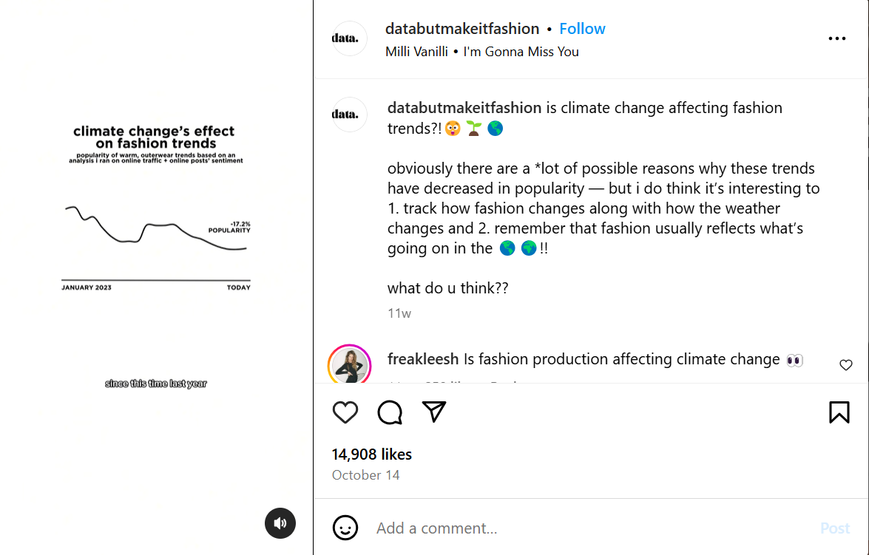
(DATA BUT MAKE IT FASHION, 2024)
This is a social media post discussing how climate change has changed fashion trends in fall and winter. To do the analysis, the author ran an analysis based on over 20,000 online media posts about cold weather fashion items and eventually concluded that climate change has decreased by 17% in the popularity of warm, outwear trends. Looking into the creator’s interview with Vogue, she mentioned she uses different platforms to collect relatable data and create content, such as Google, however, in the post I did not see a clear citation of the source of the data. Consequently, from my perspective, whether the data collected is factual is questionable, and the credibility of the source could be improved if the data is accurately cited.
As the name of the account “DATA BUT MAKE IT FASHION” shows, the account aims to use data to analyze the current fashion trend. The followers of the account are mostly people who care about fashion, or people who are interested in fashion trends, and the account itself follows mostly fashion bloggers and fashion brands. The account was created in 2019 and is frequently updated every week. Though each post may not possibly be directly related to the other, every piece of content is fashion-based and could provide followers with a sense of the current trend.
Through the comments below the post, it seems that the public indeed shares the same thoughts on the post. However, based on an objective point of view in evaluating the credibility of general social media posts, I think the lack of citation to the source of data indeed to some extent decreases the reliability of the information.

Work Cited
DATA, BUT MAKE IT FASHION [@databutmakeitfashion]. (2024, October 14). is climate change affecting fashion trends?!😲🌱🌎. Instagram. Retrieved December 31, 2024, from https://www.instagram.com/reel/DBFTSL8un1o/?utm_source=ig_web_copy_link&igsh=MzRlODBiNWFlZA==

